Low Level Design

Project Code | Group 3
Project Name | Expense Management System

Prepared / Modified by | Role | Date of preparation/ Modification
Group 3 | Analyst | 29-Aug-2018
Reviewed by | Role | Date of review
Approved by | Role | Date of Approval
Circulation List | kavya.lekhana-gurramkonda@capgemini.com  amruta.deokar@capgemini.com  ranjith.vallambhatla@capgemini.com  sejal.jain@capgemini.com  karan.upenja@capgemini.com  manasa.paidi@capgemini.com  rupesh.vishwakarma@capgemini.com  anshu.kumawat@capgemini.com | Version Number : 1.0
Version number of the work product | Version 1.0

Table of Contents

1. Description Of The Unit 3
2. References 4
3. Dependencies / Assumptions 5
4. Class Diagrams 6
5. Sequence Diagrams 7
6. Design Components 8
6.1 List of UI Components…….………………………………………….…………………………………8
6.2 List of Design Classes…………………………………………………………………………………….10

7. Reusable Routines/Components……………………………………………………. 11
8. Messages 12
9. Configuration Files 13
10. Crud Matrix Table 14
11. Data Mapping Matrix 15
12. Action Flow Matrix 16
13. Stored Procedures 17
14. Program Specification / Pseudo Code 18
REVISION HISTORY OF THE WORK PRODUCT 21
Description Of The Unit

This module is aimed at modifying an Expense Code. In this module user enters expense code, expense type and expense description and this data is updated in MySQL database. If given expense code does not exists invalid an error message will be displayed.

Administrator should be able to

- Insert Expense Code Information
- Retrieve Expense Code Information
- Update Expense Code Information
- Delete Expense Code Information
- Retrieve all Expense Code Information

References

Reference | Description
Class Diagram | D:\Expense_Code\PLP Documents\ProjectDocuments\DesignDocuments\HLD\Class Diagram\ExpenseCodeClassDiagram.png
URS | D:\Users\kagurram\Desktop\Expense_Code\Expense_Code\PLP Documents\ProjectDocuments\Requirements\CaseStudy\ExpenseManagementSystemCaseStudy.doc
UTP | D:\Expense_Code\PLP Documents\Testing\UTP\Test_Case_ExpenseCode_updateExpenseCode.xls
DB Design | D:\Expense_Code\PLP Documents\ProjectDocuments\DesignDocuments\HLD\DB Design\Expense_Mangement_Group_3DBDesign.xls

Dependencies / Assumptions
Dependencies:
NA

Assumptions:
The expense code details are stored in the MySQL database.

Class Diagrams
Class Diagram

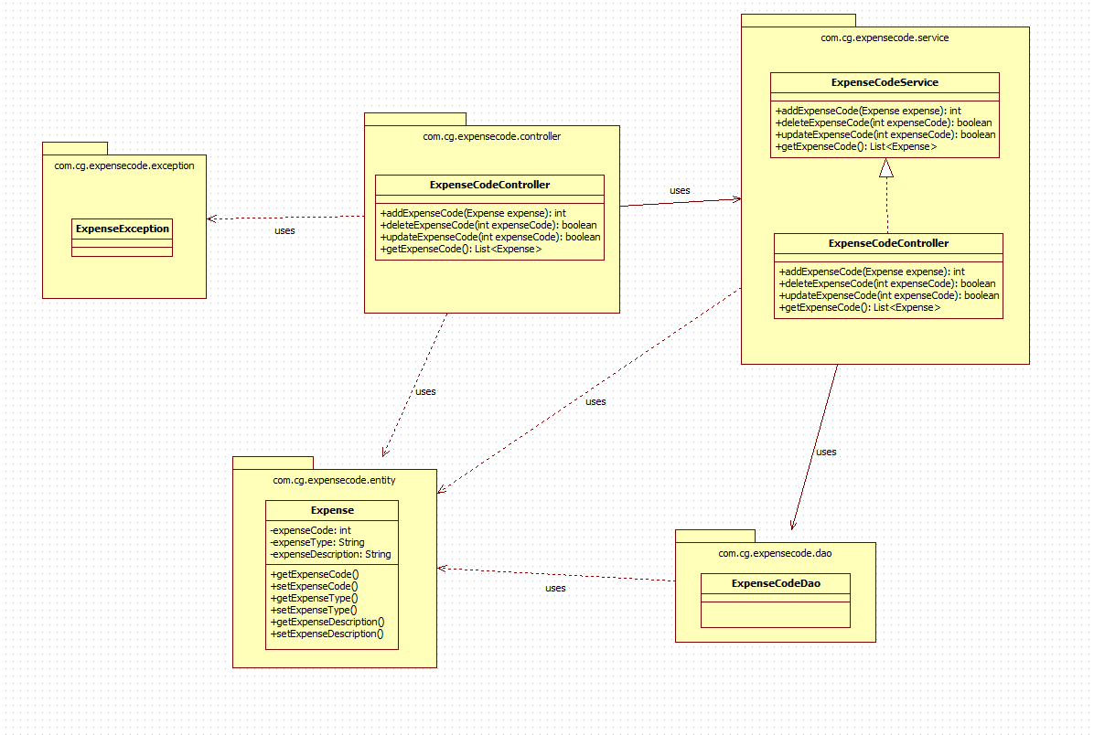

Sequence Diagrams

Sequence Diagram

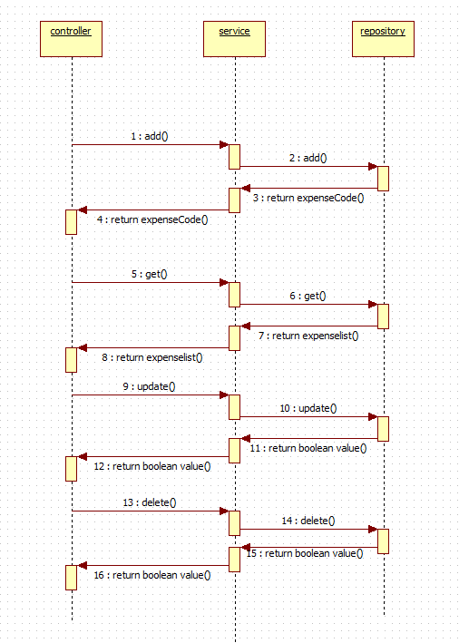

Design Components

List Of UI Components

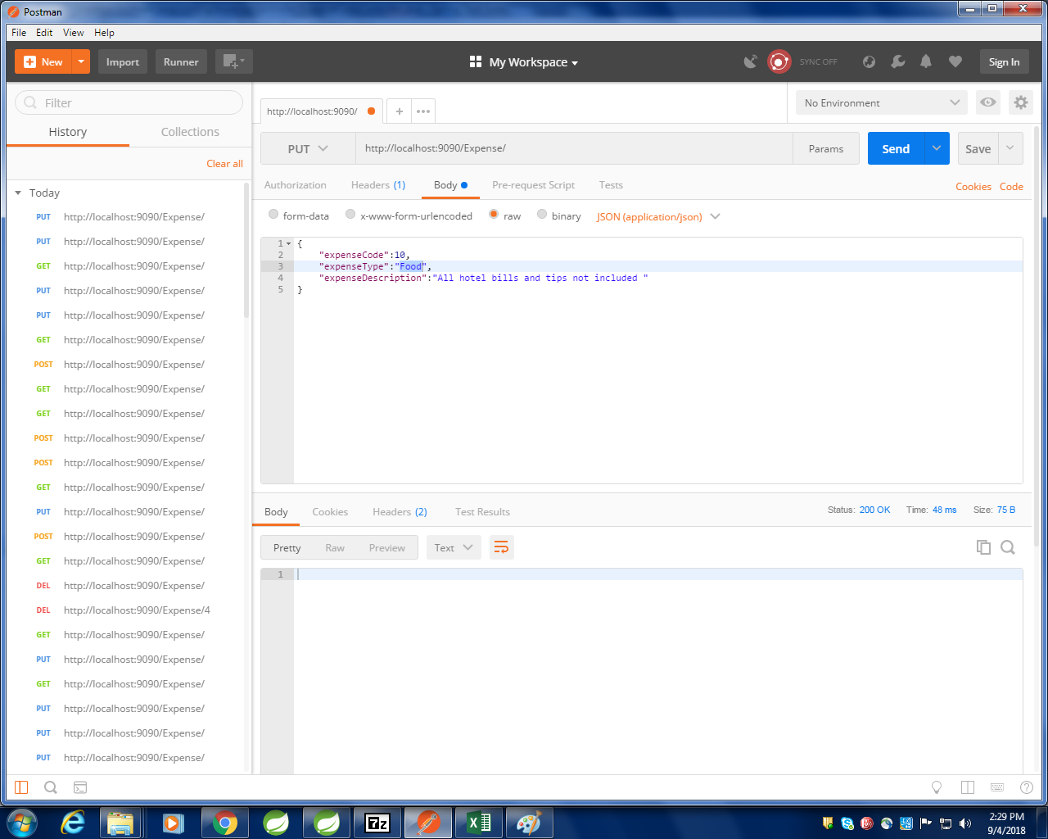

List of Design Classes

Sr. No. | LLD Name | Class Name | Method Name | Method Description
1 | Expense Code Module | ExpenseCode | Appropriate getters and setters methods | Getters retrieve the property values and setters set the property values
2 | Expense Code Module | ExpenseCodeController | public void updateExpense(@RequestBody ExpenseCode expenseCode) | Sets the model attribute.  Calls the Controller method to modify Expense Code details in to the database
3 | Expense Code Module | ExpenseCodeServiceImpl | public ExpenseCode update(ExpenseCode expenseCode) | Calls the Service layer method to add, modify, retrieve, retrieve all, delete the Expense Code details in to the database

Re-Usable Routines/Components
Re-Usable Routines/Components

- CustomizedExceptionHandler
- ErrorDetails
- ExpenseNotFoundException
- Logger properties files

Messages

Configuration Files
#. | Type | Message Text
M1 | Error | Please fill out this field
M2 | Error | Must be in characters only in range of 3 to 15
M3 | Error | Field already existed
M4 | Error | Must be in the range of 15 to 100

File Name | Path | Description
application.properties | /Development/Source | To configure database connection and port.
pom.xml | /Development/Source | To configure the dependencies

Crud Matrix Table

# | Table Name | Create | Read | Update | Delete
1 | expensecode | N | N | Y | N

Data Mapping Matrix

Sr. No. | Screen Label | Field Source | Field Type | Data Type | Max Length | Data Flow | Mandatory
 | Expense Code | ExpenseCode.expenseCode |  | int |  | UI→D | Yes
2 | Expense Type | ExpenseCode.expenseType |  | String | 15 | UI→D | Yes
3 | Expense Description | ExpenseCode.expenseDescription |  | String | 100 | UI→D | Yes

Legend

UI (User Interface Only)
UI → D (User Interface to Database)

Action Flow Matrix

Sr. No. | Action | Description | Process
1 | On Running the code in the console. | Spring Application starts. | The admin clicks on the Run button in the Spring and console generates with the success message. Then open the Postman.
2 | On changing the action panel to PUT and entering the details. | The expense code details are updated in the database. | Data is entered in the fields which gets updated into the database using Postman.

Stored Procedures

# | Stored Procedure Name  (with Description) | Input/Out Parameters | Type | Size
1. | NA

Program Specification / Pseudo Code

<ACTION: INSERT_FLIGHT_INFORMATION >

Pseudo Code:
- Client Side Scripting:
None

- Server Side Scripting:
BEGIN
Call the Service Layer for updating the expense code details into the database.
END

Pseudo Code:
14.2 <ACTION: RAISE_REQUISITION >

- Server Side Scripting:
IF Expense Type is Empty
Print Error Message M1
ELSE IF Expense Type is not in specified format
Print Error Message M2
ELSE IF Expense Type is already exist
Print Error Message M3
IF Expense Description is Empty
Print Error Message M1
ELSE IF Expense Type is not in specified format
Print Error Message M4

- Server Side Scripting:
BEGIN
Call public void updateExpense(@RequestBody ExpenseCode expenseCode) in ExpenseCodeController class
BEGIN
Call public ExpenseCode update(ExpenseCode expenseCode) in ExpenseCodeServiceImpl class in Service Layer
BEGIN
Call IExpenseCodeDao interface in Dao layer which in turn interact with JPARepository through which data gets updated.
END
Return ExpenseCode value to Service Layer
END
IF error occurs correct error message will be displayed.
END

REVISION HISTORY OF THE WORK PRODUCT
<To be maintained by projects>

# | Date | Version # | Section Changed | Details of changes made | Approved By
1
2

